16929_Two Dots

EX1)

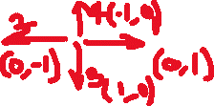

|  |  |  |
| --- | --- | --- |
| B | B | A |
| B | B | A |

* go(0, 0, -1, -1, B)
  + go(0, 1, 0, 0, B)
    - go(1, 1, 0, 1, B)
      * go(1, 0, 1, 1, B)
        + go(0, 0, 1, 0, B)

return True